Shift-Giving
Updated SWAG May 2024
Feature Level Detail
Publish Campaign
Create Post/Story
Accept Donation
Org Sign-up
Donor Sign-up
User Login
Mobile Apps Support
Push Notifications
Infrastructure
v2/Later
Support for multiple photo/video on Post
Set ‘personalized’ options to include donor info
Social media integration
Donor News/Home (v2)
Campaign Admin (v2)
Custom Messaging (v2)
Matching Donation (v2)
Money to Things Campaign (v2)
Project Level Detail
Goals of the MVP - Success Criteria
Proof of concept Spikes - technical:
Assumptions:
Project-Level Questions:
Project-Level Technical Assumptions
Project-Level Risks:
Documentation/References
Suggested Features Process

Feature Level Detail

Publish Campaign
As an org admin, I want to create a Simple Campaign so that I can set up a call to action via a Story or Post where donors can complete a one-time donation to a specific beneficiary.

A Simple Campaign is a series of Posts set up by an Org and grouped by a common purpose to meet a specific goal amount. A campaign includes the ability for users to create, edit, schedule and publish the campaign
- Create Title / Purpose
- Select Beneficiary
- Set Giving Goal
  - Org can manually modify the goal amount to reflect offline donations
- Set Start date (scheduled start)
- Start button (immediate start)
- End date (scheduled end)
- End button (immediate end)

Estimate breakdown
What’s included?
Campaign home page
Campaign create/edit screen
Basic text edit

What is the feature SWAG?

~5 months to ~8 months (includes both Simple Campaigns and Campaign Posts as of 5/29)
- Moved social media to v2 @ ~1 month

Why?
What unanswered questions?

- Which/how many methods are we using for notification?
  - Email (v2)
  - Push
- Do we need to worry about moderating content - video/audio
  - Not at this time - anticipate using other platforms that take responsibility for this - i.e. vimeo, youtube
- How much to worry about bad actors?
  - Not much - post-MVP, maybe the ability to quickly shut down an org/person if they are misbehaving

What risks?

Reference Images
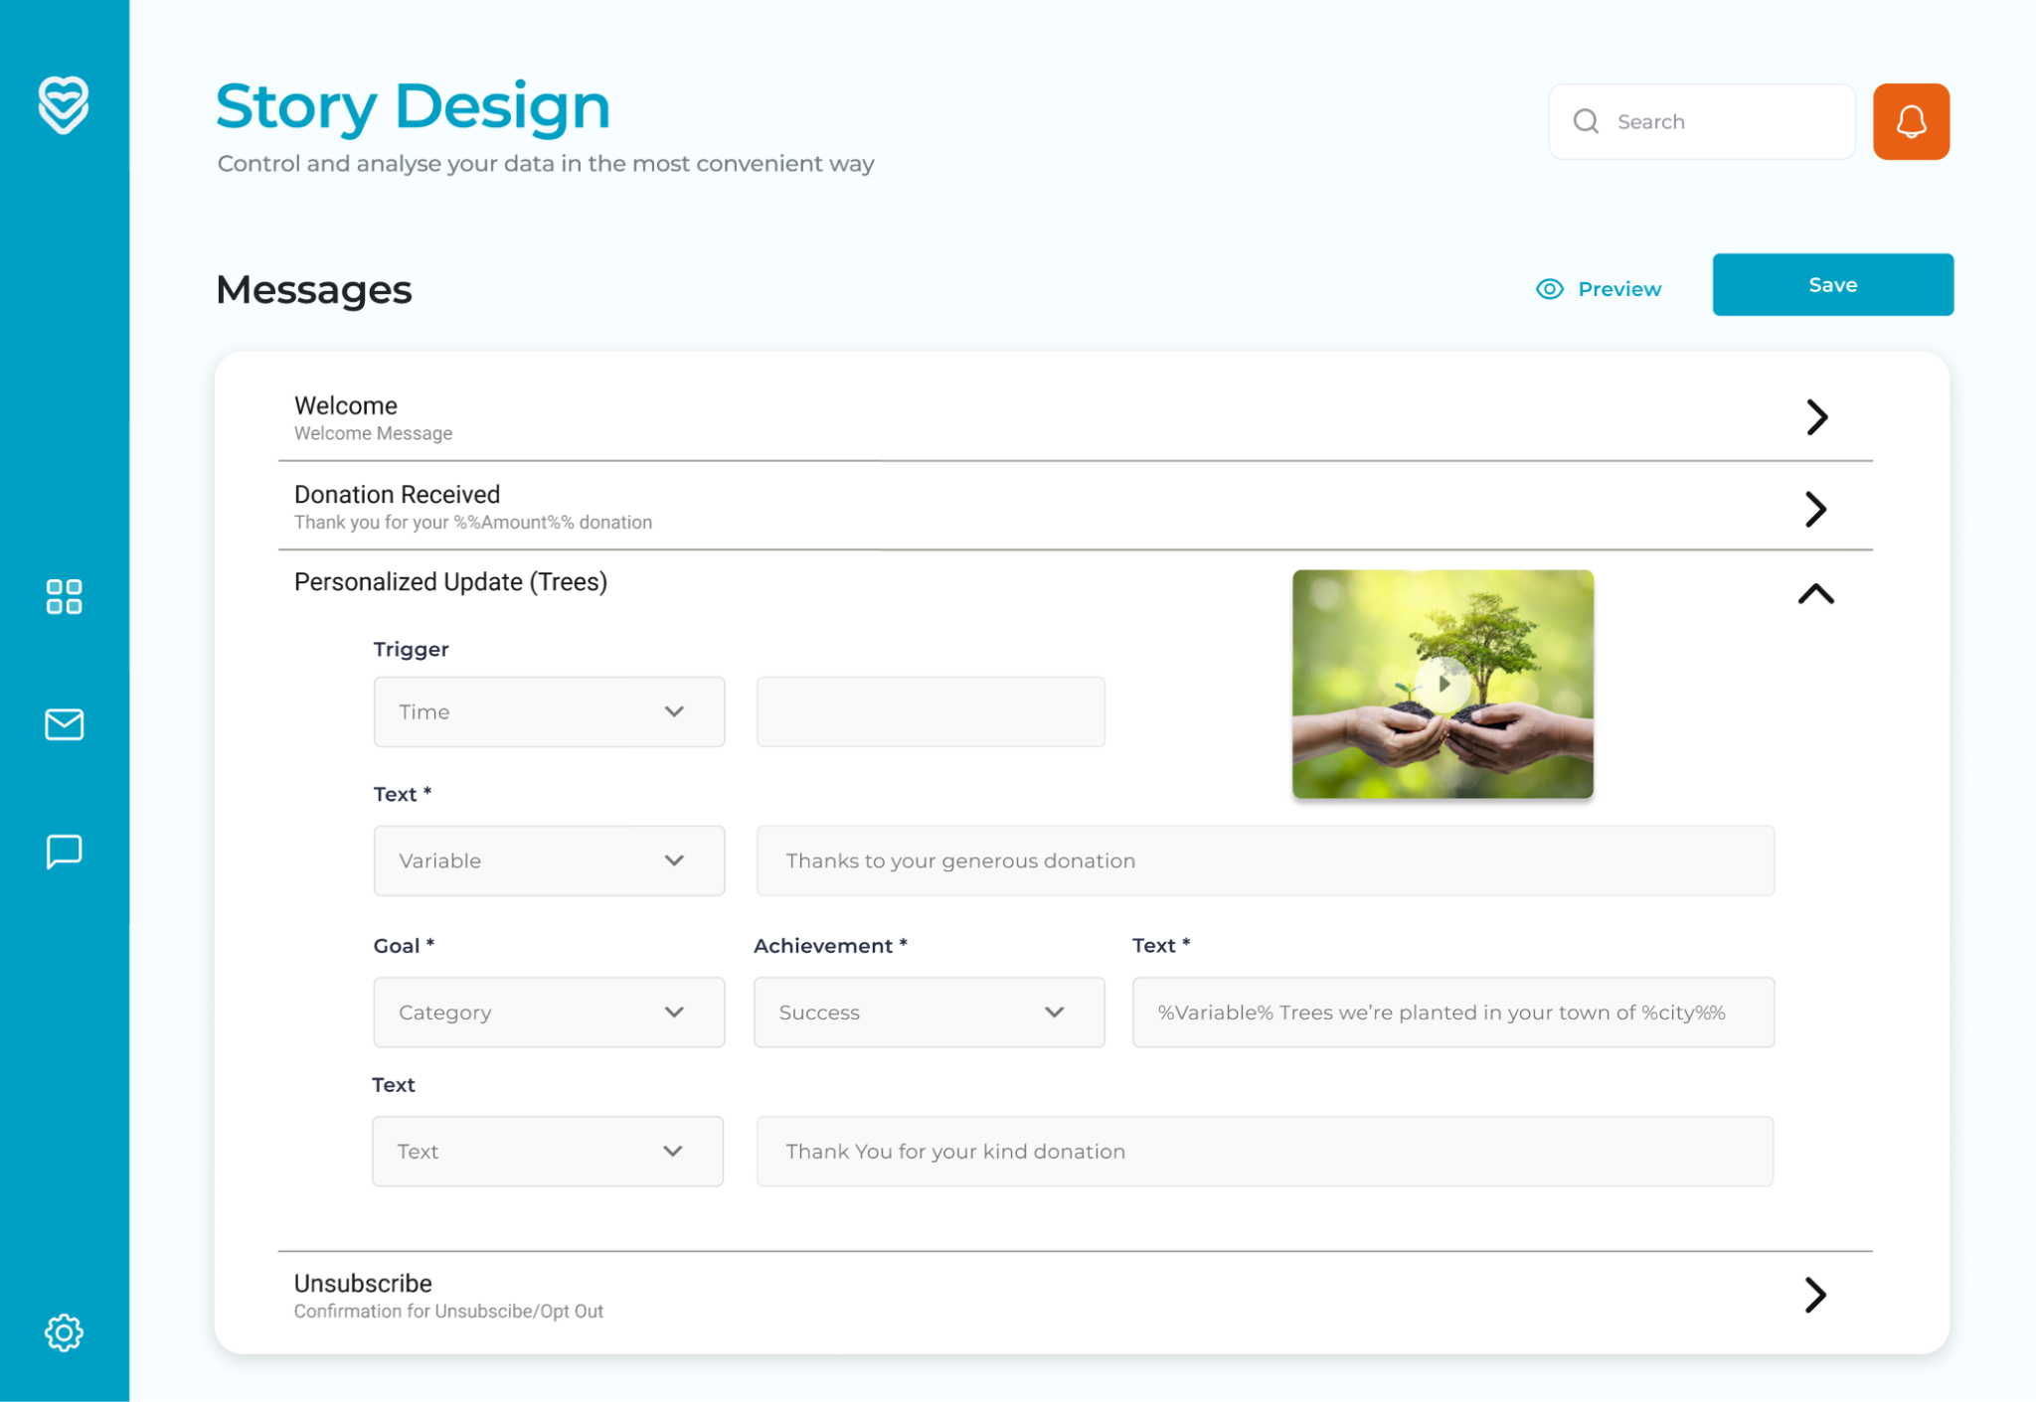

Create Post/Story
As an Org user, I want to create a Story / Post associated with a campaign so that I can refresh the call to action to donors and promote new content for the campaign.
A Donor will see posts via their app news feed, via social sharing, or via push messages.
- Upload one photos to a post
- Uploading one video to a post
- Add description text - no rich text for MVP
- Set ‘include goal/progress graphic' option
- Set push notification options
- For now - static share buttons no functionality
Future: Set ‘share to social’ options
  - Can they integrate current social media platforms?
  - API fees for existing platforms
- Set up news feed-specific content -Not customizable
  - Thumbnail of the post pic (or generic image if none uploaded?)
  - Pull the first 100 characters of the description
- Debatable MVP: Preview Post
- Save Post
- Publish Post

Estimate breakdown
What’s included?
Post create/edit screen
Notification provider
Basic text edit

What is the feature SWAG?

~6 months to ~9 months
- social media = ~1 month

Why?
What unanswered questions?

- Which/how many methods are we using for notification?
  - Email
  - Push
What Risks?
Lack of clarity on user experience around video
- Hosting
- Delivering video to donor on post
  - Upload on PC
  - Upload on mobile
  - Display on post
  - Display on campaign homepage
  - Allow to display 720p or 1080p max res
- High cost associated with this feature

Reference Images

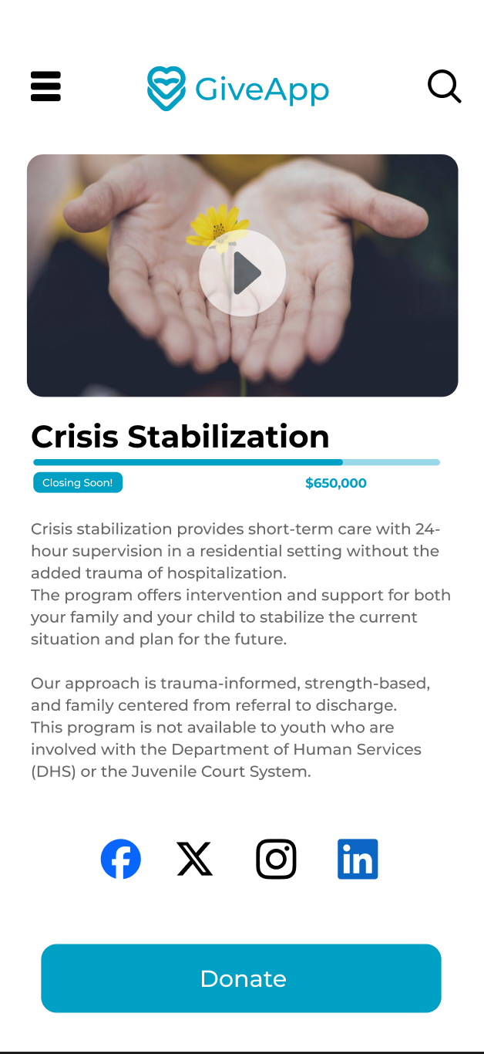

Accept Donation
As a donor interacting with a campaign/post, I can complete a one-time payment donation to a specific beneficiary or cause.
- Select amount
- Confirm amount
- Enter Payment Details
  - Handled by payment processor?
  - Or we handle everything?
    - JM has screenshot example of going out to browser
- Submit donation to account
- Trigger Donation confirmation/Thank you (push)
- Email Tax receipt
  - For tax purposes, what info is required?

Estimate breakdown
See Brian’s breakdown of payment processor options here: https://docs.google.com/spreadsheets/d/10hSqevj9QT8knqIdfAhnlZWmSif-fy_1/edit#gid=1993570804
Can look at Yestaurants code for example
TE app works like this too?

What’s included?
- Redirect to web page
- Build page for entering payment info
  - Option to save
  - Pass to Authorize.net
  - Check for existing customer
- Redirect back to confirmation page or troubleshooting error
- Fire confirmation email
What is the MVP feature SWAG?

~1 month

Why?
What unanswered questions?

- Is there a limit on how much a donor can give in a one-time transaction?
    - Hard cap on MVP app-wide - $2500
  - Can org control this and set threshold?
    - Later, yes
- Is there a limit on how many transactions can be completed in short time? (i.e. fraud, abuse)
  - Holding period helps mitigate this
  - Payment processor support is likely here also
- Credit card, debit, and ACH?
  - No ACH MVP
  - CC only in MVP
- Google Pay/Apple Pay support?
  - Not MVP
- Do we need to provide legal info or disclaimer - fee transparency, refunds, money-handling detail?
  - Some simple disclaimer for MVP - text on page
- Do they need to be able to save payment details/method in the app?
  - No, CC info stored in Authorize.net
  - ACH info -
  - Immediately MVP or eventually?
- Is a donor always a singular person, or can it be an org/group?
  - Anything with a credit card
  - Will this result in differing requirements for receipts/tax purpose
- How long to hold in cold storage/record retention?
- Can donations be made in someone else’s name?
  - Not MVP
  - Future feature
- Assume US dollars?
- Are we facilitating refunds?
  - API can reverse charges
  - Will need to contact support, not automatic through our app
  - will have to factor in holding period/payout timing
- We are reseller partners with Payment processing: Accept payments anywhere | Authorize.net , USAEpay, NMI, ChargeAnywhere, IPOS, Eprocessing Network and Accept Blue.

What risks?
- Smaller processors may not have a credit card vault and expose us to more risk around encryption and storage of payment info
- Provider costs can be onerous for processing and storage, we need to come up with some model to help us balance features and costs
- Will need to think about later needs to produce finance/accounting reports on campaigns

Reference Images
- Not literal recipe but a future state mockup
- Can we put non-functional elements in to suggest future features?

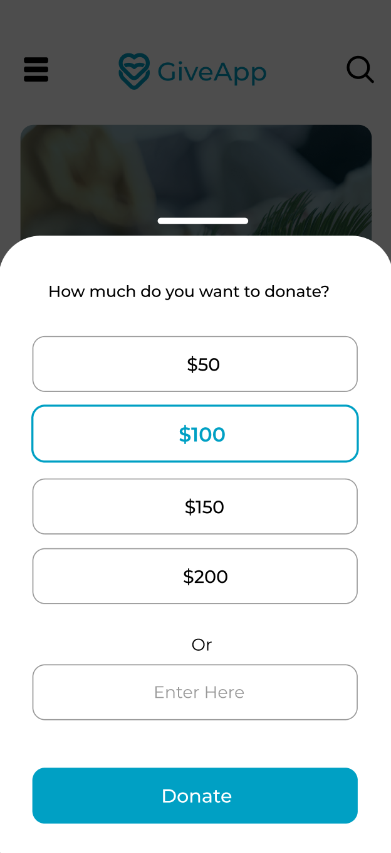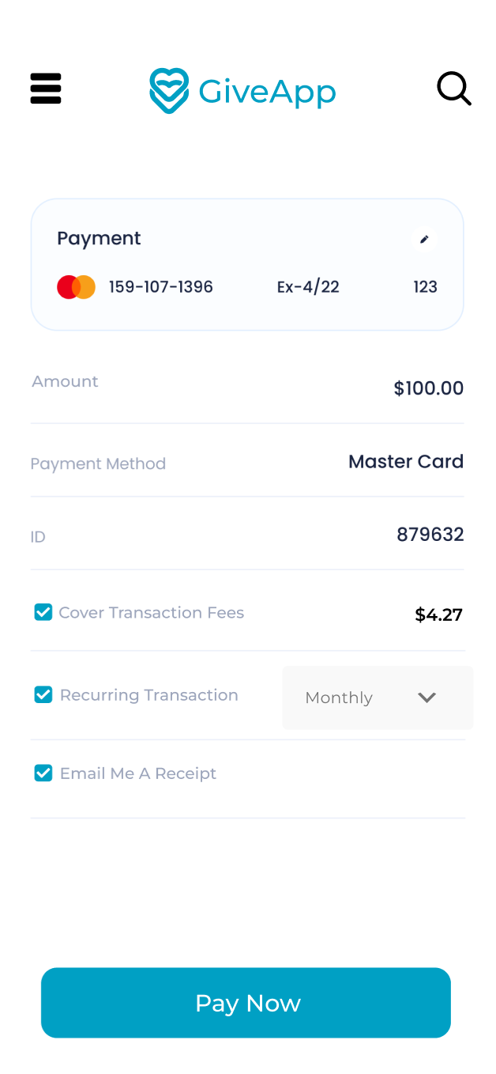

Org Sign-up
As a prospective user of the Giving app, I want to sign-up for the platform and register my organization.
Sign-up on web
- Org Name
- Upload logo - not req
- Owner First name
- Owner Last name
- Org Address
  - Any mailing address
- Email address
- Nonprofit EIN
  - nine-digit tax ID number that IRS assigns to nonprofits, charities, organizations, and businesses in the following format: XX-XXXXXXX
  - Validation process?
- Set Password

Estimate breakdown
What’s included?
- Sign-up page with fields
- Required field handling
- Submit button

What is the feature SWAG?
~1 week

Why?
What unanswered questions?
Only one user, or multiple with admin

What risks?

Reference Images
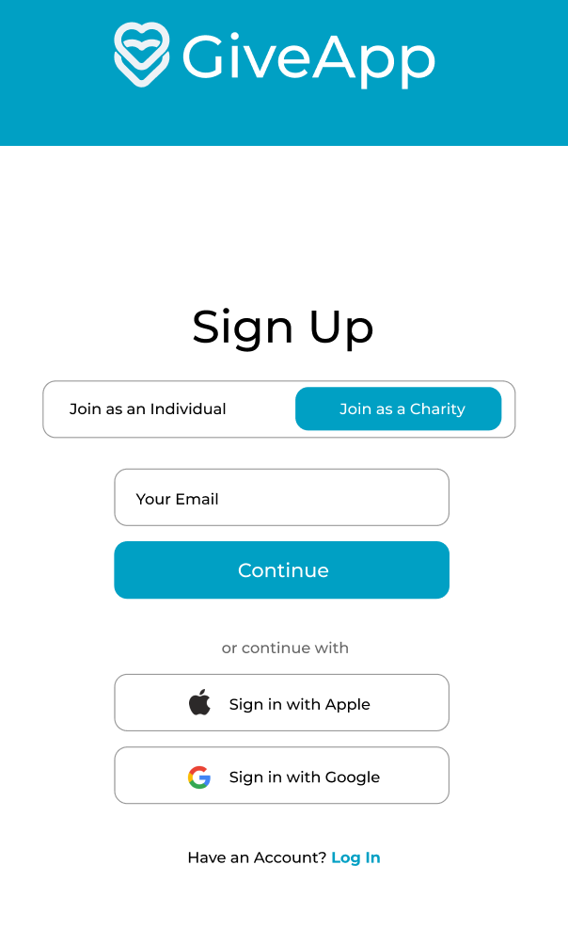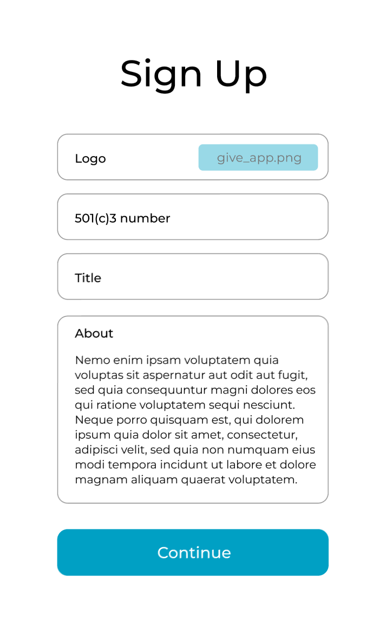

Donor Sign-up
As a prospective donor user of the Giving app, I want to sign-up for the platform so I can engage with organizations, campaigns and posts, and donate to beneficiaries.
App only
- First Name
- Last Name
- Business Name (optional)
- Email address
- Physical address
- SSN/TIN
- Phone number
- Set Password
- Upload profile photo (not MVP)
- DOB

Estimate breakdown
What’s included?
- Sign-up page with fields
- Required field handling
- Submit button

What is the feature SWAG?
~3-4 weeks
Why?
What unanswered questions?
What risks?

Reference Images
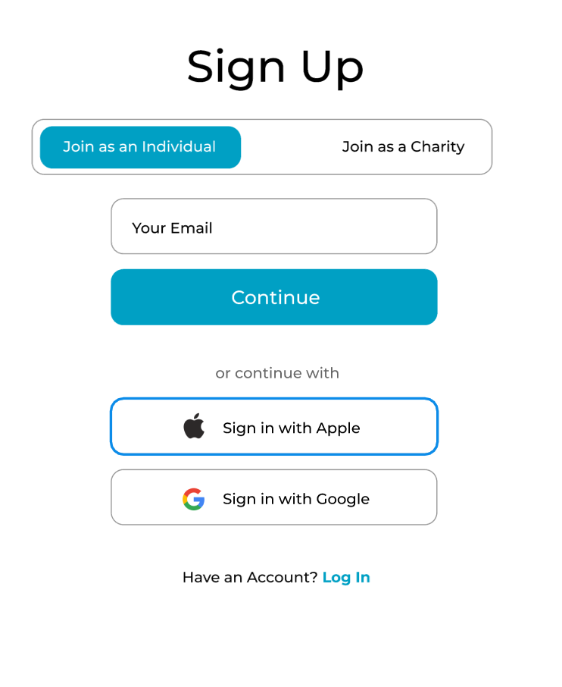

User Login
As a prospective user of the Giving app, I want to log in to the platform successfully or get help logging in if needed.
Assumption - devise will handle most of this out of box, if we identify extra effort, can estimate separately
MVP -
- don’t let users be both org and donor
- don’t let org user manage multiple orgs from one login
- BH to deep dive on questions re: Jumpstart and other libraries re: future-proof for multi-tenancy
- Ehren to review capability of devise on token support/setup

What’s included?
Login page (web & mobile)
Forgot/Reset PW page (web & mobile)
Devise install/setup

Estimate breakdown
What is the feature SWAG?
~1 week

Why?
What unanswered questions?
-how would MVP implementation of this affect multi-tenancy
- JWT/token questions

What risks?

Reference Images

Site Admin
As a site admin user,

MVP -
Assign Org Admin
PW resets
Lock user account
Create org
Create campaign

Analytics (later)
Site-wide reports
Donor Giving history (all orgs)

Account Settings
Notification preferences

Mobile Apps Support

As a donor user, I need to access iOS and Android apps -
ID data structures and types
Test env for mobile
Building out custom components for reuse across many screens
App Navigation setup

View campaigns
View posts
Donate
Account Settings
Subscribe/Unsubscribe to Org

View donation history

Estimate breakdown
What is the feature SWAG?
~2-3 months

Why?
What unanswered questions?
What risks?

Reference Images

Push Notifications
As a prospective user of the Giving app, I want to receive push notifications when:
- Posts are published in campaigns that I follow
- Campaign is created by org I follow
- Campaign updates
  - Goal percentage
  - Content updates
- Reminders - Custom messages
- Recurring donation reminder
  - Heads up day before that donation will hit tomorrow
- Donation Thank you
- Campaign end Thank you
See Ehren’s research and detail here:
https://shiftinteractive.atlassian.net/browse/GIV-17?focusedCommentId=76138

What’s included?
FCM setup - register iOS and Android apps
Import JSON file
Configure Keys
React Native/FCM SDK install
Perms request on initial app load
Store FCM token (if allowed) in our db
Frontend: Process and display notifications
Backend: Setup notifications in Ruby app to target subscribed users
Segmentation logic for specific events/orgs and subscribed donors

Estimate breakdown
What is the feature SWAG?
~2 weeks

Why?
What unanswered questions?
What risks?

Reference Images

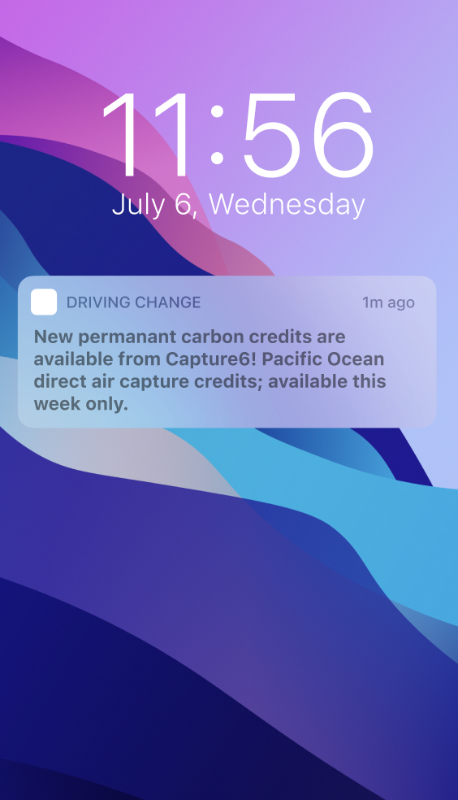

Infrastructure

Mono-repository

Environments

- Production
- Staging

Application Architecture

- Mobile Apps (Used by Donors)
  - React Native
    - iOS
    - Android
- Web Application (Used by Organizations/Administrators)
  - Ruby on Rails
- API (Used by Web Application/Mobile Apps)
  - Ruby on Rails
- Database (Used by API)
  - Postgres

AWS

- ECS
- ECR
- RDS

Terraform - Infrastructure as Code
Buddy - Deployment Pipelines
CircleCI - Build and Test Pipelines
Mailgun - Sending Emails
FCM/APNs - Sending Pushing Notifications (iOS/Android)
Cloudflare - Configure DNS

Questions we need to answer:

- How do we need to integrate with the payment processor(s)?

- Will our application be international or just domestic?
  - MVP no, but thinking about it for v3 is reasonable.
- Does our application need to support multiple languages/currencies?
  - Recommend adopting some of the standards from the start to ease transition later
  - Spanish language support envisioned in later versions

- How do we want to handle uploading and storing photos?
  - S3, CDN we handle vs a service
  - Free vs Pro differences later
- Will we need to worry about storing videos?
  - MVP could be fairly manual
    - Consider letting orgs host on their account in MVP and share link
  - Later: integrate to Vimeo Pro API (our account is the target for uploads, not client)
- How will our application handle communication to users?
  - Email
    - Minimal as possible for MVP
    - Simple Donor receipt only - send user back to app
  - Push Notifications
    - MVP - push only
  - SMS
    - No for MVP - will be for v2/later
- How do we intend on handling Social Media integrations?
  - No for MVP - will be for v2/later
- What is our testing strategy?

Backlog Cards (so far…)

- Setup/Configure Repository
- Setup/Configure CircleCI

- Setup/Configure AWS for Staging
- Setup/Configure Terraform for Staging
- Setup/Configure Buddy for Staging
- Setup/Configure Testflight for Staging
- Setup/Configure Google Play for Staging
- Setup/Configure Mailgun for Staging
- Setup/Configure FCM for Staging
- Setup/Configure APNs for Staging
- Setup/Configure Cloudflare for Staging

- Setup/Configure AWS for Production
- Setup/Configure Terraform for Production
- Setup/Configure Buddy for Production
- Setup/Configure Testflight for Production
- Setup/Configure Google Play for Production
- Setup/Configure Mailgun for Production
- Setup/Configure FCM for Production
- Setup/Configure APNs for Production
- Setup/Configure Cloudflare for Production

v2/Later

Support for multiple photo/video on Post
(limit 5 pics, 2 vids, for example)

Set ‘personalized’ options to include donor info

Social media integration

Donor News/Home (v2)
Value Story: As a donor, I want to see a multi-tenant feed of subscribed organizations, campaigns, and posts so that I can engage with rich storytelling.

Acceptance Criteria:
- When viewing a list of campaigns/posts, I’m able to

Estimate breakdown
What is the feature SWAG?
Why?
What unanswered questions?
What risks?

Reference Images

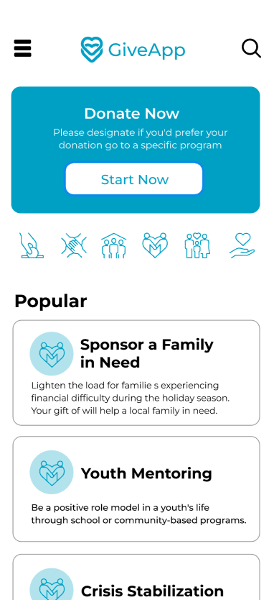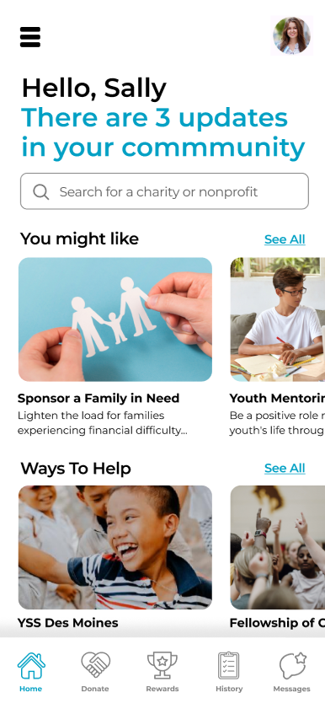

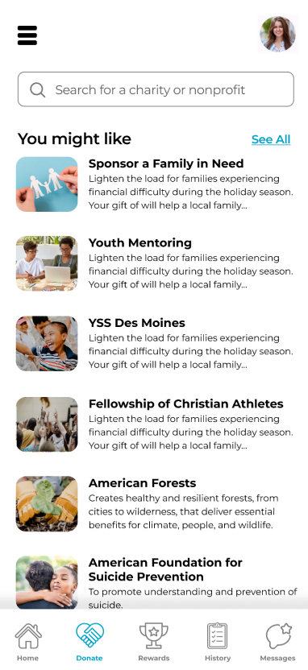

Campaign Admin (v2)
Value Story: As an organization, we want to be able to manage existing campaigns so that we can keep opportunities for donations up to date.

Acceptance Criteria:
- When viewing a list of their existing campaigns, organizations are able to view/edit existing campaigns

Estimate breakdown
What is the feature SWAG?
Why?
What unanswered questions?
What risks?

Reference Images

Custom Messaging (v2)
- Set Thank You message text (per donation)
- Set Thank you message text (end of campaign)

Matching Donation (v2)
When match happens, need to roll that into the goal amounts - if $1 direct give = $3 with match
Think about time-based OR funds-based windows for match
How to show match visually in the app

Money to Things Campaign (v2)
The idea of donor giving money but it “equals” x amount of diapers. Would need some ability to customize the goal details on a campaign such as the description text, the unit of measure for the goal

Mobile Campaign Create/Edit support (v2)

Org Contributors -
As an org user I want to invite users to my org as contributors. with low-level perms, these contributors can
submit content to media library for use by org admins
Contributors can create/edit posts

Project Level Detail

Goals of the MVP - Success Criteria
- Prove out technical assumptions/burn down risks
  - Not so much, we trust our ability to deliver tech

- Testing business ideas
  - Will orgs sign up and pay to use?
  - Will donors sign up and engage/donate?
  - Can we forecast a cost-efficient platform?
      - Up-front costs
      - Ongoing costs
    - At what time post-launch can we recoup the cost?
      - How early can we forecast hit/miss?

- Post-Launch
  - Platform Growth - Orgs
  - Platform Growth - Donors
  - User Engagement
  - User Retention

Proof of concept Spikes - technical:
- Payment processing/handling of money - Brian
- Push notifications - Ehren

Assumptions:
- Estimating MVP features only - later phase ideas should be put in parking lot/low backlog priority
  - include infrastructure, delivery, sprint zero

- Product Owner: Justyn Miller
- Delivery Lead: Cliff Thompson
- UI/UX/XD: Chris Johnson
- Dev Team: 3 full-stack developers

Tech Stack:
  - Ruby on Rails
  - React Native
  - AWS
  - Docker
  - PostGres
  - Buddy
  - Circle

Other pieces needed:
  - Provisioning profiles
  - iOS - Testflight
  - Google Play - Internal Testing lanes
  - Payment Processor
  - Push/Notification
  - Photo hosting
  - Social media sharing/embedding/
  - Video Lib
    - Dev reqs
    - Pricing/Feature analysis
  - Verify 501c3 status
    - https://developer.candid.org/docs/charity-check-1
  - Recommendations engine

Project-Level Questions:
- Should we include any portion of Super Admin capabilities in MVP? From earlier WAG doc
- (not initially per 5/22 all w JM)
  - As a super admin, I should be able to to CRUD all donors
  - As a super admin, I should be able to to CRUD all organizations
  - As a super admin, I should be able to to CRUD all organizations campaigns

Project-Level Technical Assumptions
- We need environment for web app as well as mobile

Most basic Donor user flow:
- Download the app
- Create a new account
- View a list of campaigns I can donate to
- Pick a campaign to donate to
- Donate

Most basic Org user flow
- Create account
- Login
- View a list of campaigns
- Create campaign
- Edit campaign detail

Project-Level Risks:
- If the team that estimates the work is not the team that does the work, estimates or assumptions may not be fully accurate or well understood by the future team.
- Until the business goals and Success Criteria are further understood or formalized, there will be some lack of efficiency aligning priority and user value to features design.

Documentation/References

- Shift Giving WAG Estimate (2023)
- Figma Documentation Pre-MVP WAG era
- Pitch Deck
- Payment process research

Suggested Features Process
What are MVP features that we want to deliver?
  - Feature One
    - What is the SWAG?
    - Why?
    - What risks? What unanswered questions?
      - Mitigate, Accept, or Defer
Estimate should include:
- Developing the feature
  - Configuring infrastructure
- Prep/time refining cards
- Demos
- Establishing analytics

Total Estimate should include:
- Sum of each feature estimate
- Time for Sprint Zero (2-3 weeks)
- ~20% time

